Prim’s Algorithm=
#include <stdio.h>
#define MAX 10
#define INF 999

int main() {
int n, i, j;
int cost[MAX][MAX];
int visited[MAX] = {0};
int min, u = 0, v = 0;
int totalCost = 0, edges = 0;

printf("Enter number of vertices: ");
scanf("%d", &n);

printf("Enter cost adjacency matrix:\n");
for(i = 0; i < n; i++) {
for(j = 0; j < n; j++) {
scanf("%d", &cost[i][j]);
if(cost[i][j] == 0)
cost[i][j] = INF;
}
}

visited[0] = 1;

printf("\nEdges in MST:\n");

while(edges < n - 1) {
min = INF;

for(i = 0; i < n; i++) {
if(visited[i]) {
for(j = 0; j < n; j++) {
if(!visited[j] && cost[i][j] < min) {
min = cost[i][j];
u = i;
v = j;
}
}
}
}

printf("%d - %d : %d\n", u, v, min);
totalCost += min;
visited[v] = 1;
edges++;
}

printf("Total Cost = %d\n", totalCost);

return 0;
}
Output =
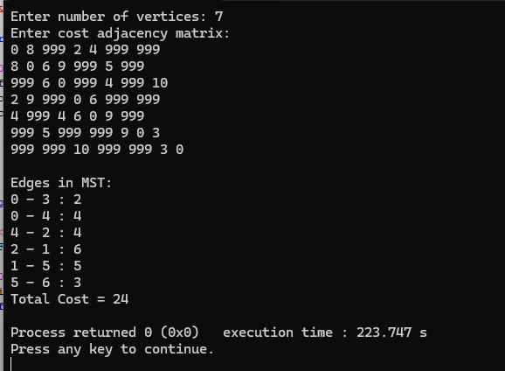
Kruskal’s Algorithm=
#include <stdio.h>
#define MAX 20
#define INF 999

int find(int parent[], int i) {
while(parent[i] != i)
i = parent[i];
return i;
}

void unionSet(int parent[], int u, int v) {
int a = find(parent, u);
int b = find(parent, v);
parent[a] = b;
}

int main() {
int n, i, j;
int cost[MAX][MAX];
int parent[MAX];
int totalCost = 0, edges = 0;
int min, u = 0, v = 0;

printf("Enter number of vertices: ");
scanf("%d", &n);

printf("Enter cost adjacency matrix:\n");
for(i = 0; i < n; i++) {
for(j = 0; j < n; j++) {
scanf("%d", &cost[i][j]);
if(cost[i][j] == 0)
cost[i][j] = INF;
}
}

for(i = 0; i < n; i++)
parent[i] = i;

printf("\nEdges in MST:\n");

while(edges < n - 1) {
min = INF;

for(i = 0; i < n; i++) {
for(j = 0; j < n; j++) {
if(cost[i][j] < min) {
min = cost[i][j];
u = i;
v = j;
}
}
}

if(find(parent, u) != find(parent, v)) {
printf("%d - %d : %d\n", u, v, min);
totalCost += min;
unionSet(parent, u, v);
edges++;
}

cost[u][v] = cost[v][u] = INF;
}

printf("Total Cost = %d\n", totalCost);

return 0;
}
Output=
